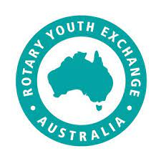

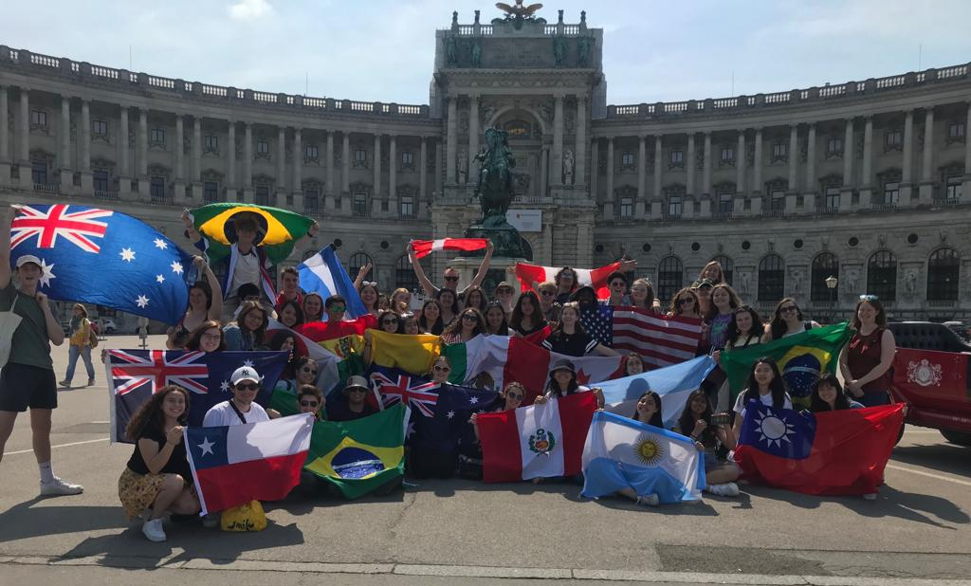

What does the program cost?
The Rotary District RYE package estimated Global Fee of $9,000 paid in instalments.
A family may spend an additional $6,000 or more during the exchange, with the major expenses being the host country tour and clothing.
A scholarship may be eligible for those families experiencing financial hardship.
What have other students thought of the program?
The following are typical of the appreciations expressed by former Rotary exchange students:
"An exchange is when strangers become family, foreigners become friends, a second language becomes like your first, and a year suddenly becomes days”
“Making the exchange is very beneficial and there is so much to gain by living in another country and learning their language and culture”
"I would say if you were even considering going on an exchange you should definitely apply because you couldn’t possibly regret what will be the most adventurous, busy and exciting year of your life so far. I wouldn’t change it for anything"
"Thanks to Rotary I have been able to experience this incredible year abroad. Not only have I learnt a new language and culture, and made life-long friends, I've got to travel to the other side of the world, whilst living some of the most incredible moments of my life. The year was an unforgettable journey, which I consider to be priceless"
Wow, I’m interested!
What’s next?
You will need to complete an Expression of Interest form found at:
https://www.ryea.org.au/apply-today.html
You will receive a reply answering any questions you may have about our exchange program.
In March, you will receive further information regarding finding a ‘Sponsor Rotary Club’ along with access to the application form. After your sponsor Rotary Club interviews and endorses your application, you will receive information about the selection weekend.
- Applications close: 20th April 2024
- Selection interviews may be in Gladstone, Cairns & Darwin May 2024
- Orientation weekends -September & early December
- Debrief upon return
So if you’re ready for a positive life-changing experience…
Contact your local Rotary Club or:
Heather Sugget D9560 Rotary Youth Exchange Program Chair
Telephone: 0400 553 295
Email: rye@rotary9560.org

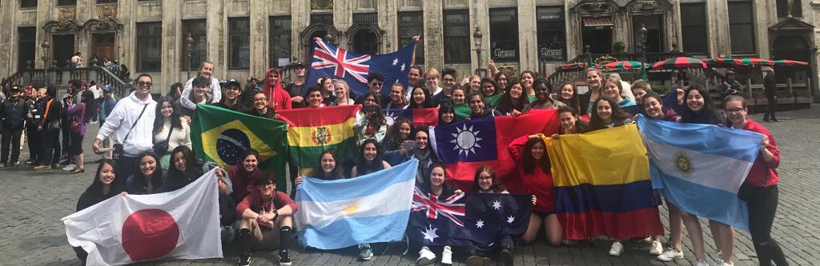
One of the GREATEST experiences of your life is being a…


Rotary Youth Exchange Student!
If you want to:
- be a young ambassador, helping to bring the world closer together
- make life-long friends in another country
- learn a new language, intercultural understanding, and more about yourself
Then being a Rotary Youth Exchange Student could be for you!
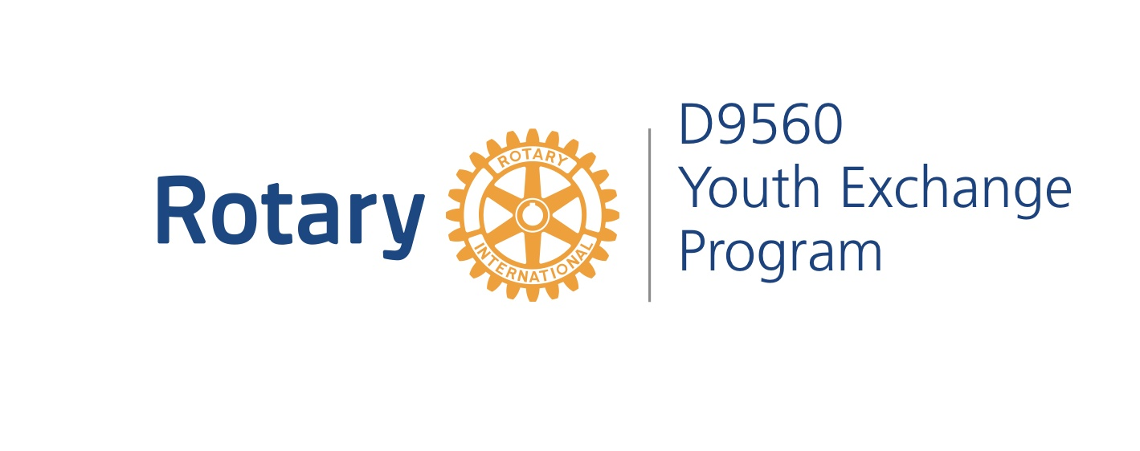

Where can a student go?
Students have the opportunity to nominate preferred countries of exchange that are available. Whilst we endeavour to meet preferences, students must be prepared to accept the country chosen for them.
These countries include but not limited to: Austria, Belgium, Brazil, Czech Republic, Denmark, Finland, France, Germany, Italy, Japan, South Korea, Sweden, Switzerland, The Netherlands and Taiwan.
Not all countries are available each year.
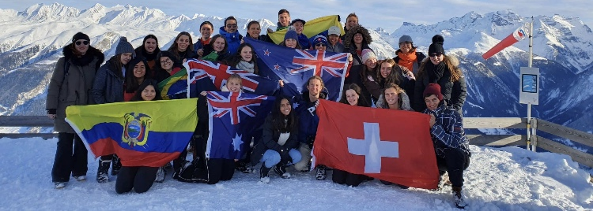
What does the 12 month program provide?
- return airfares from Australia to your host country
- Visas
- comprehensive travel and health insurance
- 12 months accommodation with two or more families
- a monthly allowance of A$130 (approx.)
- administration and counsellor support to look after your welfare
- selection day
- two orientation weekends
- blazer, hoodie/shirt, badges, business cards.
- debriefing in January/February on your return
- support for your parents and your host families

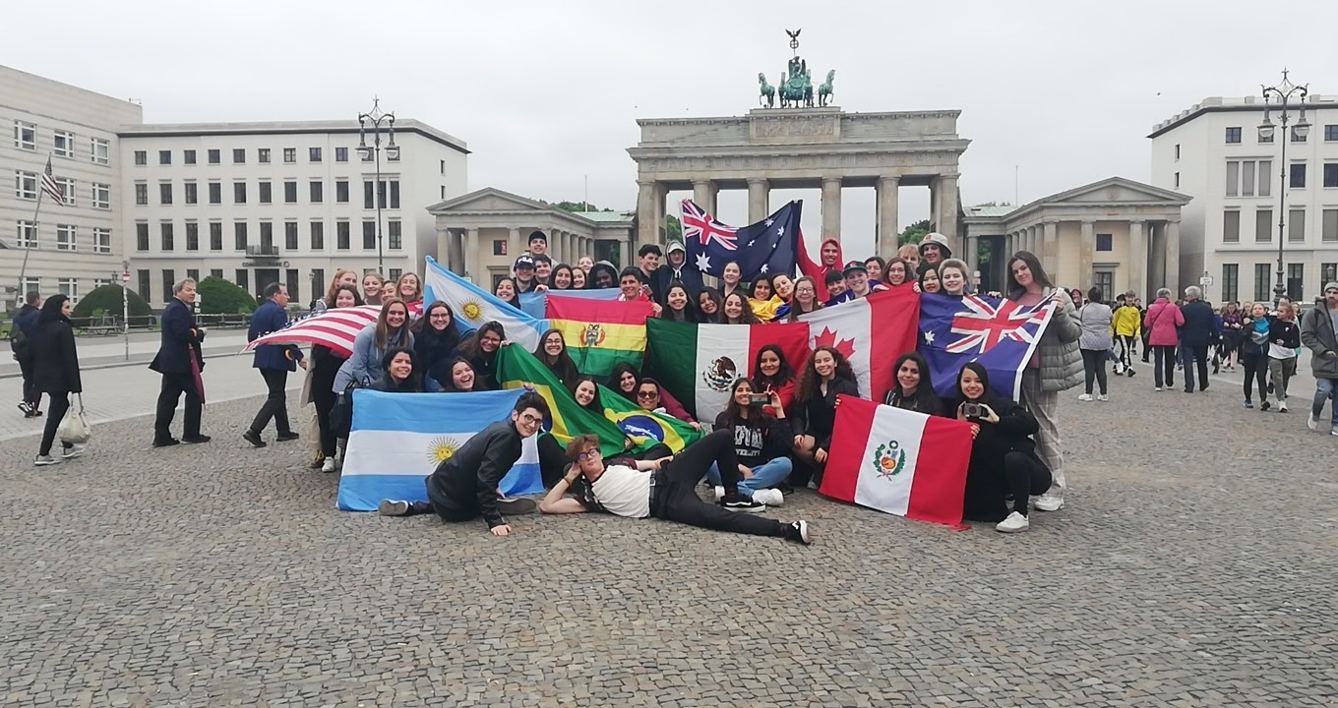
What do you and your family provide?
- travel to the Embassy for biometric test and interview if required
- spending money (apart from the monthly allowance)
- language course online or in host country
- student tour organised by host country
- specific clothing for winter conditions
- gifts and souvenirs
- travel cost to selection, orientation weekends & debrief and community development
What are the family expectations?
Rotary Exchange is a reciprocal program; we send a student overseas and we receive a student from that country the following July. We ask that you provide contact details of two suitable families that would be happy to host an inbound student from twelve to sixteen weeks over the next 18 months.
This is a most rewarding opportunity to be involved in for the family to get to know and understand another culture and to make a new friend from the other side of the world.
As a Rotary Youth Exchange Student in 2025
You will spend a year living with host families in another country, learning a new language, a new way of living and a great deal about yourself.
You will be a young ambassador helping to bring the world closer together and making some life-long friends in the process. Whilst you will be busy learning, the people you meet will be learning too, about your country, culture, and ideas.
What a great gift you will receive and give.
What are the program requirements?
- preferred age is between 15 and 17 years 6 months at the time of departure in January
- satisfactory academic record
- maturity and strength of character
- degree of adaptability
- good family relationships and possible hosting availability
- ability to communicate well with people
- friendly personality
- full-time school attendance in your host country
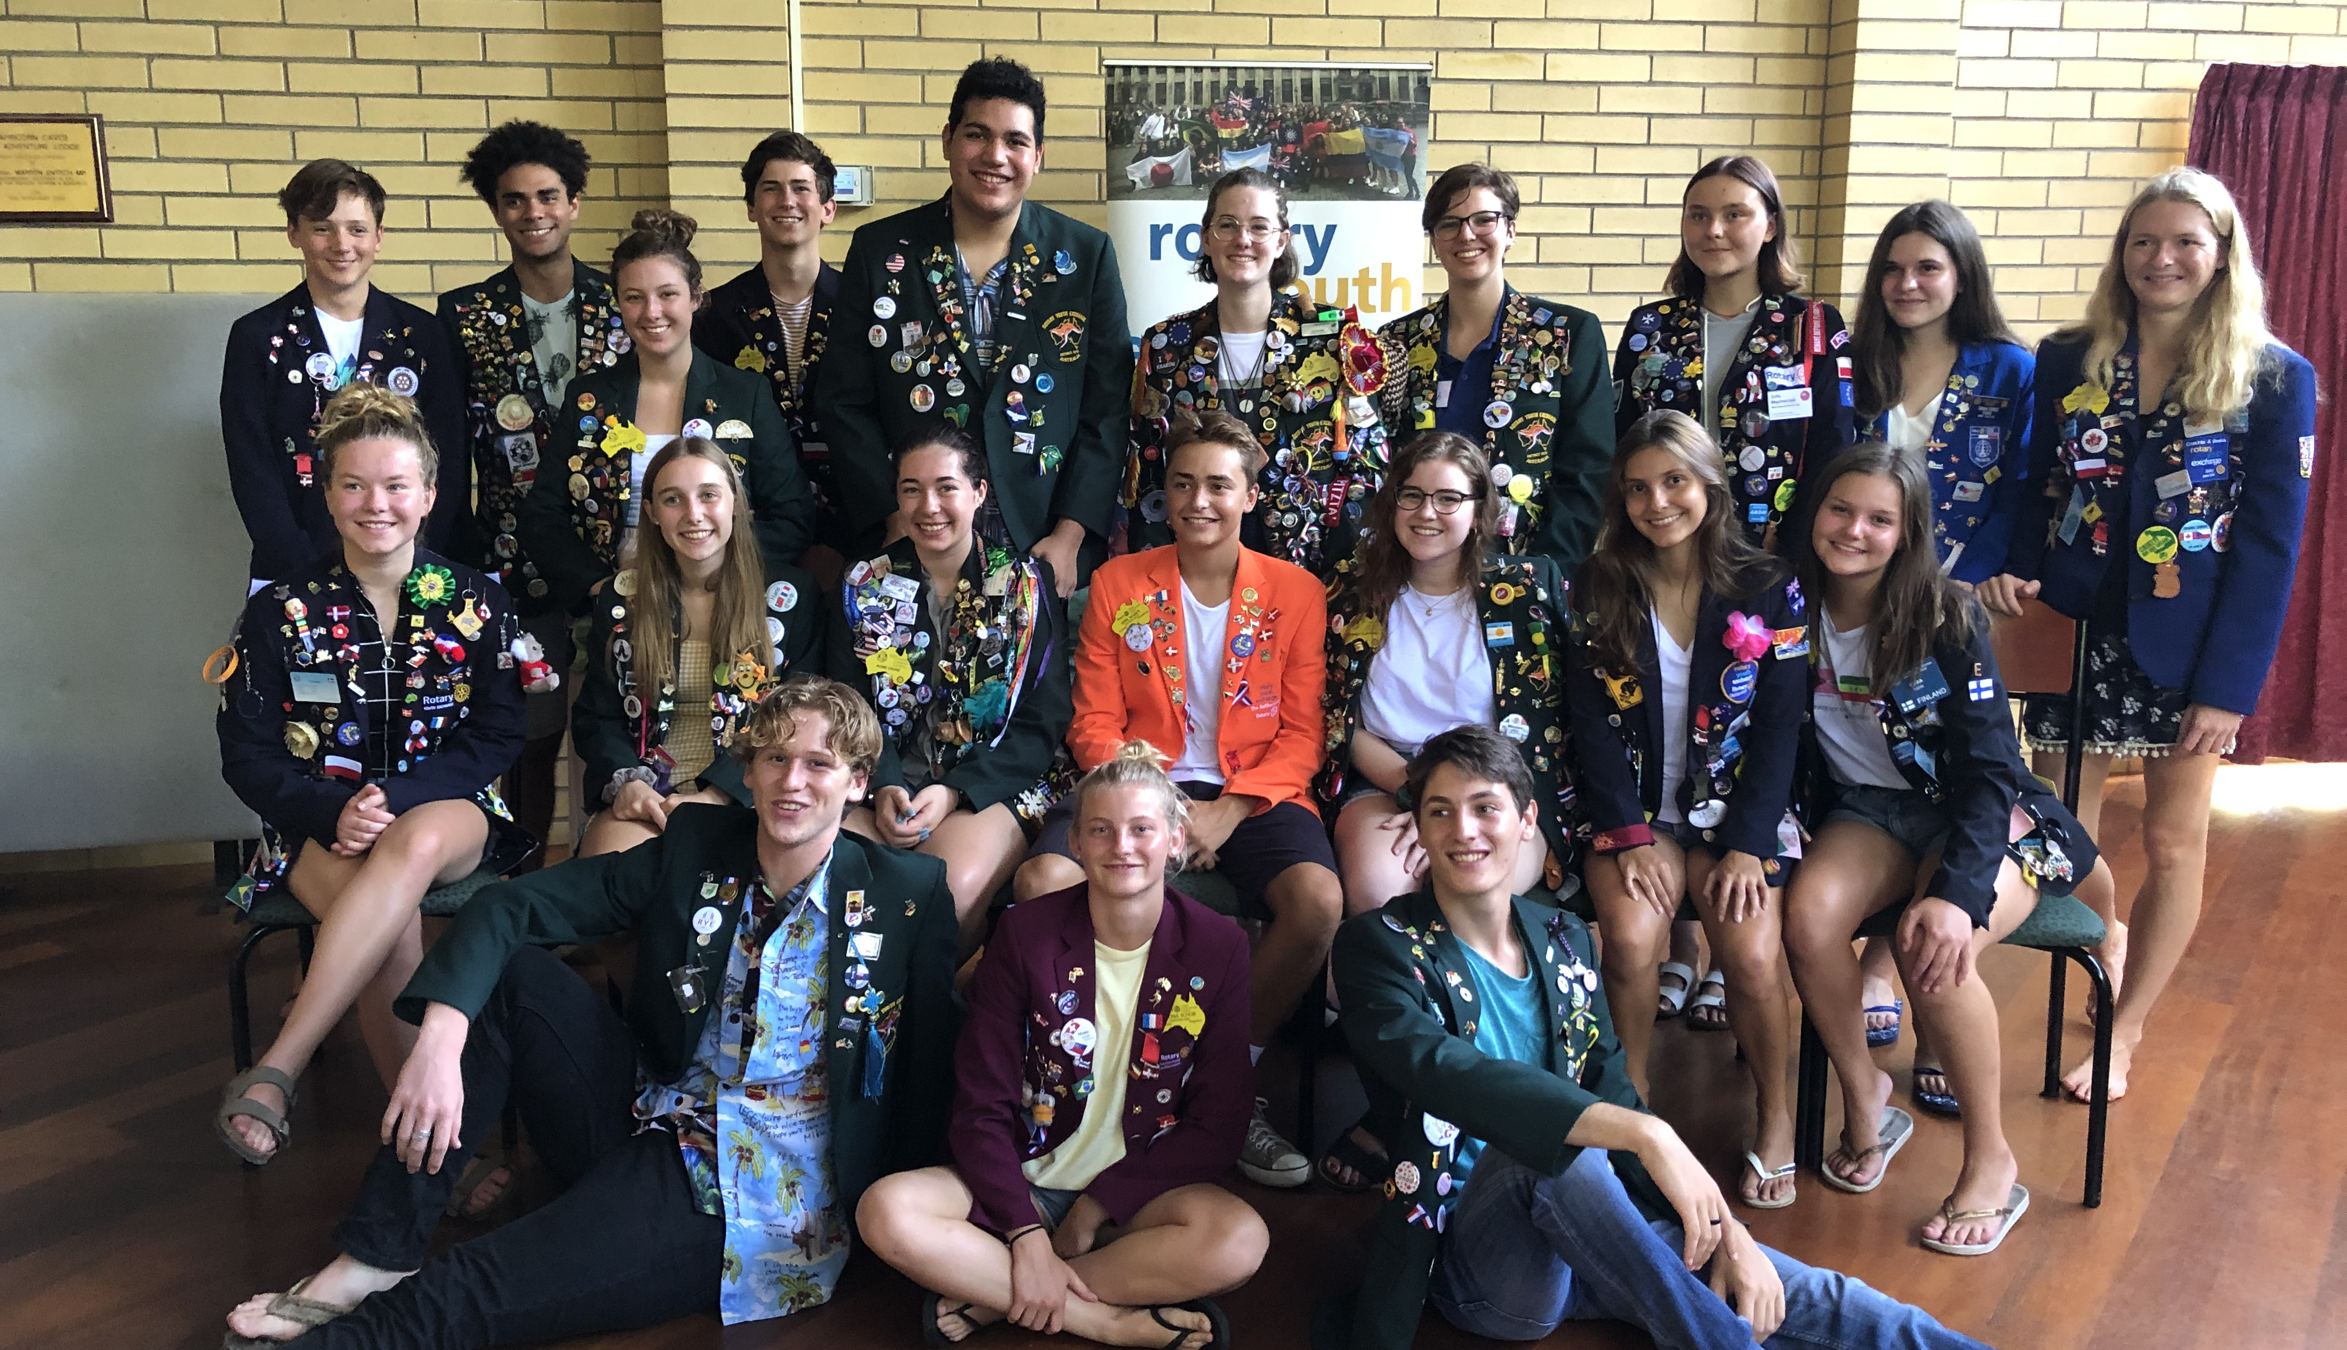

FIRST INSIDE PAGE
MIDDLE INSIDE PAGE
LAST INSIDE PAGE

