12 March 2024

Dear Parents / Carers of Year 7 Students

In Term 2 your son or daughter will be involved in an outdoor education camp, held at Chaverim. The camps will be in Core Studies classes, so the students will go out with their Core Studies teacher or in some instances, another teacher.

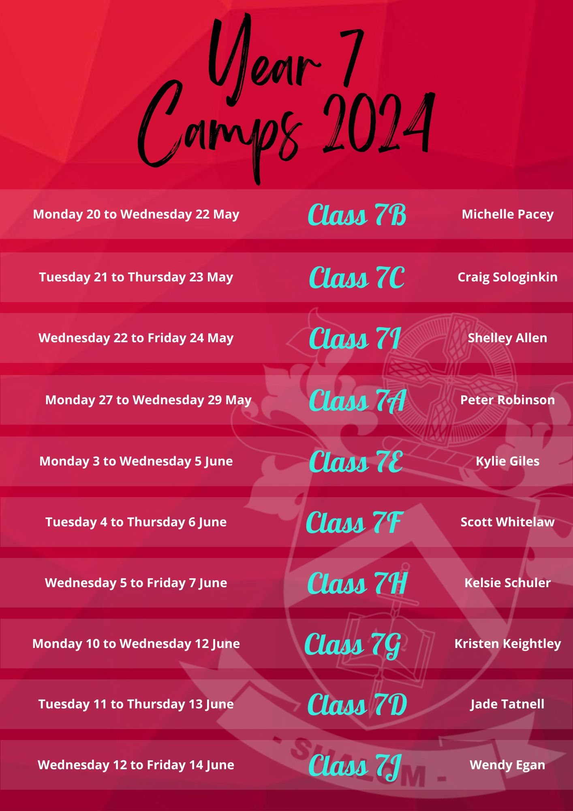
These Outdoor Education programs aim to provide an additional approach to the personal and spiritual development of your child and the greater Shalom community. This three-year program has specific objectives designed to provide.
- An atmosphere of cooperation between students, which can be applied at school, in the family and on the sports field. This may be characterized by cooperation, encouragement and concern for fellow students.
- Knowledge, skills and attitudes that contribute to a sense of responsibility, self-reliance, cooperation and harmony within oneself, with other people, and with the natural environment.
- Opportunities for participants to develop knowledge, low level skills and attitudes for participation in a number of outdoor pursuits.
- Knowledge, skills and attitudes towards a ‘minimum impact ethic’ consistent with the environment in which activities take place.

Each participant involved in the program will be given the opportunity to:
- “Look into the mirror” to see how their behaviours, both good and bad, impact their fellow participants.
- Participate in physically and mentally challenging activities while remaining safe on physical, mental and emotional levels.
- Experience and practice Christian values by living and working together in an open and encouraging atmosphere.
- Develop low level skills in a number of outdoor activities as well as a basic understanding of the associated equipment and safety precautions.
- Experience achievement in a non-competitive ‘win-win’ environment.

The camp also gives the teacher and students the opportunity to get to know each other well.

NO PHONES ARE ALLOWED ON THESE OUTDOOR EDUCATION CAMPS AT CHAVERIM.

The staff in charge will collect phones at the start of camp and return them just before 3.00 pm on day three. Alternatively, keep the phone at home for safe keeping.

I am sure the students will survive without their phones for 3 days and then they can focus on the outdoor education opportunities. If students need to call home for any reason the staff will let them use the phone at the Chaverim office.

The students will be transported to Chaverim by the College bus on the first day of camp. Students will need to be at school by 8.30 am the morning of the camp; they will return to the College at approximately 2.45 pm in time to catch the bus etc on the third day of camp.

Please find attached:

- Camp Program
- Equipment List - Clothes should be functional and suitable for outdoor and adventure activities and provide adequate protection from the elements. Camp is not a time to be fashion conscious; clothes need to be very practical. Students are also to be reminded that Chaverim is a Shalom College campus and all the usual College expectations apply. The wearing of unnecessary jewellery, make-up and inappropriate clothing is not permitted.
- Administration of Medication to Students form - if your child requires medication while on Camp please complete the form and hand it to your Teacher prior to departing on Camp.

Please login to Parent Lounge to give permission for your child to attend the Camp.

Once there click on the ‘Events and Payments’ tab and you will find a link to Year 7 Camp. Here you will be able to give permission for your child to attend, as well as view details about the camp. You will also be asked to review and verify that your child’s medical details are correct.

To check your child’s medical information is current, please click on the ‘student details’ tab and go to ‘medical details’. Please make sure that the following sections are completed so that your child can participate in all activities on camp.

- Can Swim 25m
- Tetanus Up-To-Date
- Medicare Number

In the ‘medical conditions’ section, click ‘add new’ and you will see a drop-down box and notes section where you can also note any dietary requirements, sleeping issues and other details that you feel may be relevant to your child’s well-being at the camp. Once you are happy with the information you have provided, please click ‘verify’.

Please also check your contact details and phone numbers are current, as we will be using this information to contact you if needed.

It is very important that all information in the Parent Lounge is current as teachers will use this information in case of an emergency and to support the wellbeing of your child.

If you require assistance with Parent Lounge login, please contact the office. If you have any further queries, please do not hesitate to contact me here at the College by phone or email.

Yours sincerely

Peter Robinson
Student Welfare

